

Training Created by:



Sales Process Training

The Process Builder feature is useful for automating processes and routine tasks, as well as keeping track of specific actions, and automating workflow. Although only 1 sales process may be attached to a opportunity at a time, Sales Processes can defined as a single part of the total business process and linked together to create a total workflow tool.

Elements of a Sales Process
Sales process can be configured to accomplish quite a variety of objectives. A careful approach can yield very useful results. It is important to consider your options when creating your sales processes. Sales processes can be created independently and linked together just as your business process demands. It is usually best to think of sales processes as independent activities that happen in a defined portion of your business. Your entire business may be as simple as 1 process or it may be a combination of sales process that feed into each other. Each sales process encompasses one part of your business. The relationship of the process steps to the sales process and the relationship of the processes to other processes equates to the workflow of your business.

Sales Processes can be used to;
- Track Activities
- Automate Emails
- Trigger Task Groupings
- Automate routine data entry
- Define Workflow

*Sales Processes can only be attached to an Opportunity and cannot be directly connected to a Contact or an Organization.

Examples:
- Track Activities
Key determinates can be tracked by creating sales processes as Action Items
    - 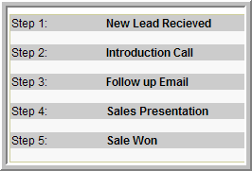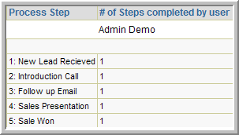
Process Step Activities Report (Opportunity>>Report>>Process Step Activities)
- Automate Emails
Example; On day 1 send email template ABC, On day 10 send email template XYZ, On day 21 send Email template DEF
  - 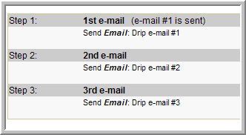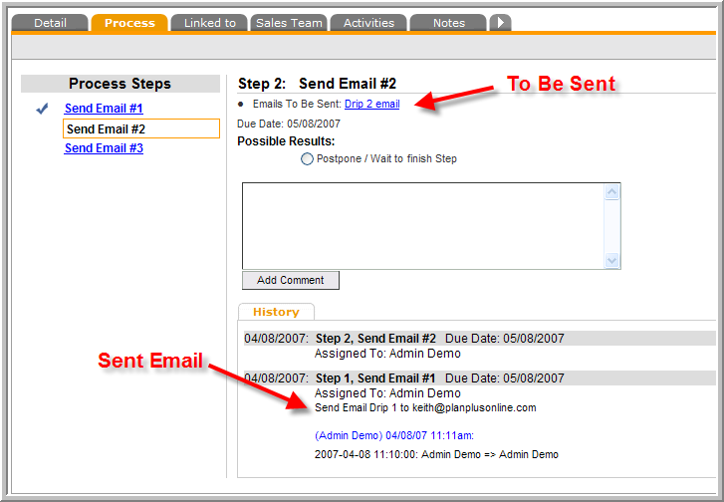

- Trigger Task Groupings
Trigger a series of Tasks that all belong together.
  - 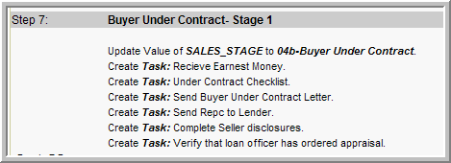

- Data Entry Routines
If you find yourself updating the same fields with the same data, the sales process can automate this routine data entry.
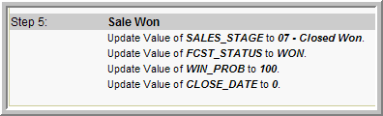

Advancing a Process Step
Attaching a Process to an opportunity gives the opportunity a Due Date. These due dates can be tracked on the users task lists and can be used to report activity. To keep the opportunities current and to give credit to the proper person for completing the tasks, the process steps must be advanced.

The current process step is located on the Process tab of the Opportunity Detail Screen. Opportunities can be advanced in 3 ways;
- From the Opportunity Detail page
- From the Task List
- From an Email (requires Email Boomerang to be configured)

1- From the Opportunity Detail Page:
Select one of the Radio buttons und the “Possible Results” heading.
OR,
Select on of the underlined Process steps in the left column. (if these links are not clickable, you must configure the option to “allow free branching of process steps” in Process Builder admin section.)
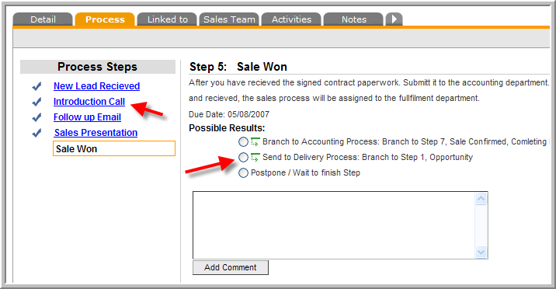

Once you have selected one of the radio buttons, the comments box will change to a box that includes some addition fields.
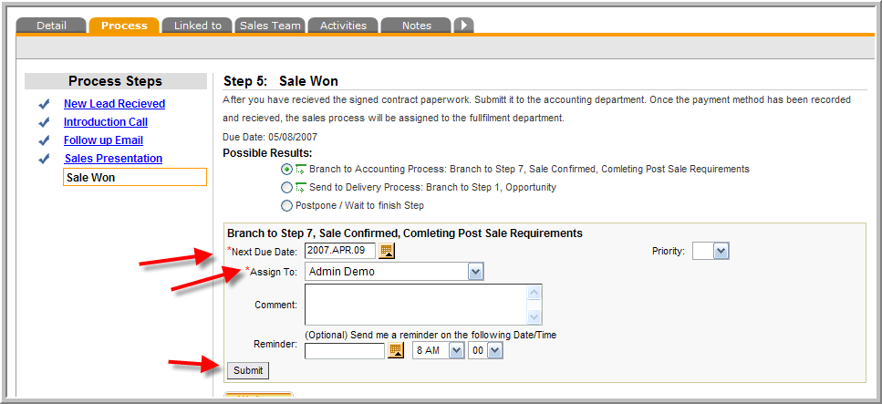
The Next Due Date is the date that the next process step will be due. The Assigned to is a dropdown menu that shows all users that you can assign the next step to. Comments allow for your notes. Priority allows you to set the priority of your next step. The Submit button confirms your selections.

Note: The opportunity name will be displayed on the task list of the assigned user on the Due Date.

2- From the Task List, click on the “In Progress” dot. Select “Completed”
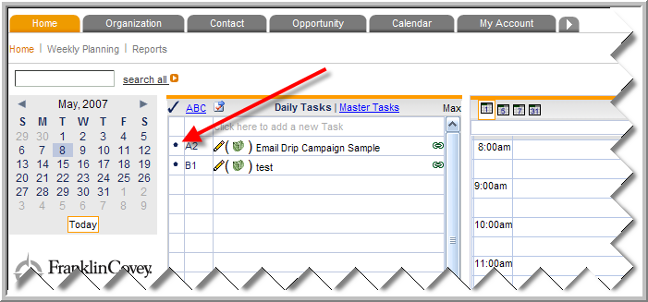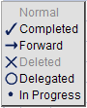

A Pop Up window will be displayed that has similar options as the Process page of the Opportunity Detail Screen.
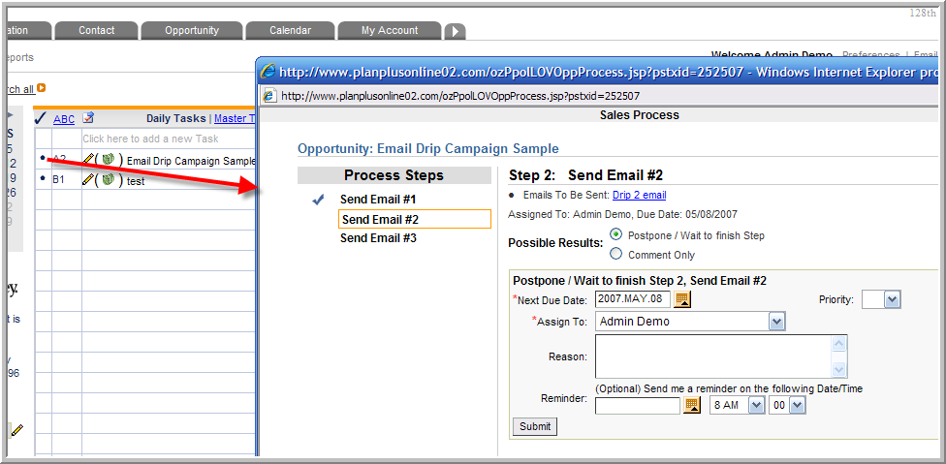

3- From an Email (using Email Boomerang ^{tm})
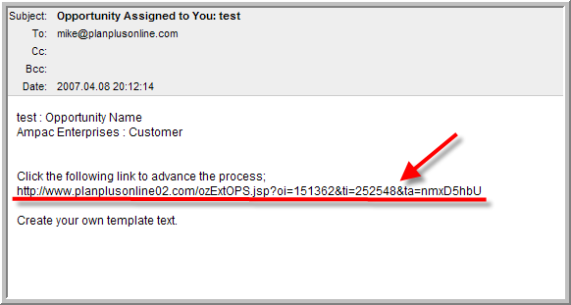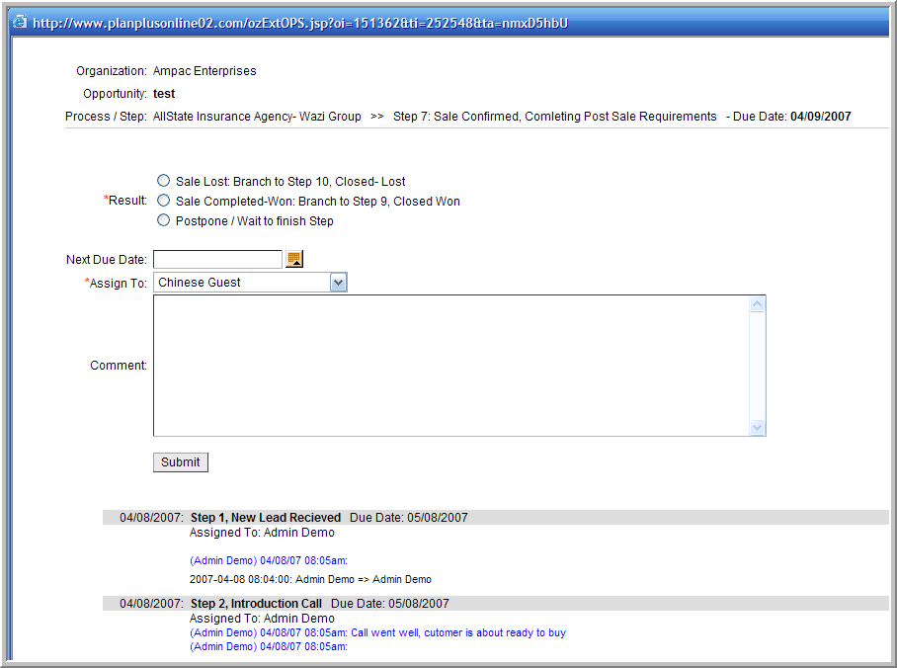

Configuration Options
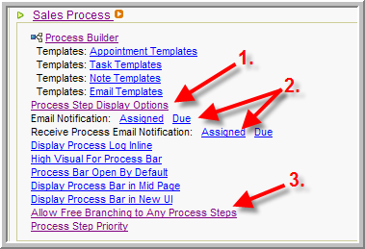

- Process Step Display Options-
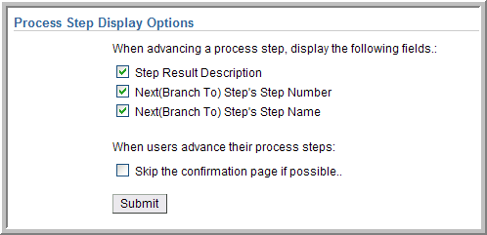
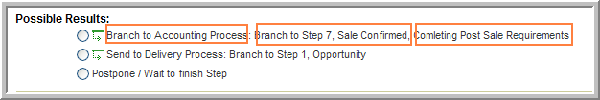

- Email Notification
Allows you to configure the settings for the Email Boomerang. The template and the On/ Off toggles for the Assigned vs. Due settings. See the section on Email Notification that follows.

- Allow Free Branching to Any Process Steps
Free Branching “ON” Free Branching “Off”
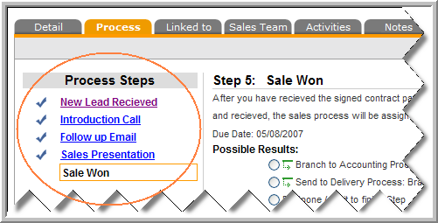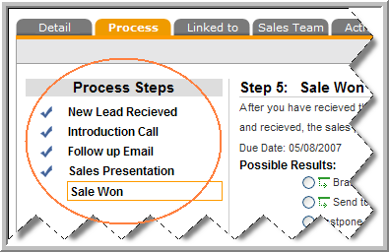

Additional Settings
Draft vs. Published- Opportunities that are in the Draft status are not usable by users. All processes must be published before they can be attached to opportunities.
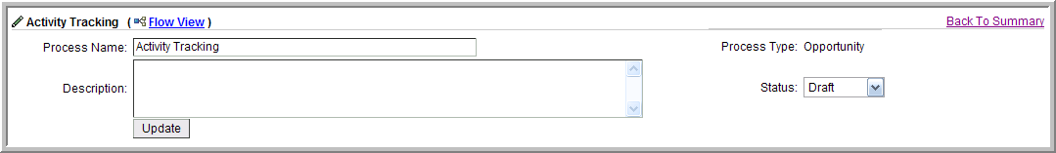
Create Process Steps
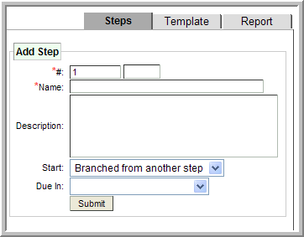
#: Consists of a Number (1-99) and a Letter (A-Z) in the second box.
Start: The first step of a process will “Immediate” all others will be “Branched from another step”.

Email Boomerang
The steps of a sales process can be delivered via email to any user in your database. By configuring the Email notification options, you can create a secure link to your database that can send basic sales process information between you database and your users email accounts. When you configure this option, the Assigned user receives an email that contains a link. The link displays a page that allows the user to indicate the result of the current process step and select a due date for the next step. The email recipient can also add a string of comments and see any previous comments. This is all done without the need to remember a password or log in to the database.

Email Notification is comprised of 2 elements;

Receive Process Email Notification: ( On/ Off ) When a process step is assigned from one user to another, it is considered “Assigned”. You will need to determine if you want to send notifications when these processes steps are assigned. Processes also have a “Due Date” this is the date that the Opportunity is due. On this day, the opportunity will be displayed on the Assigned users task list.
If you would also like the assigned user to receive an email on the due date, select this option to Yes.
If you select YES, the email notification will be sent when the lead is assigned/ due. If you select NO, the email will not be sent when assigned/due.

Email Notification (Template Configuration) You can select separate templates that are sent to the users email account. Use the merge fields to create your own template. The only required link is the : ##PROCSTEP_EXT_URL##

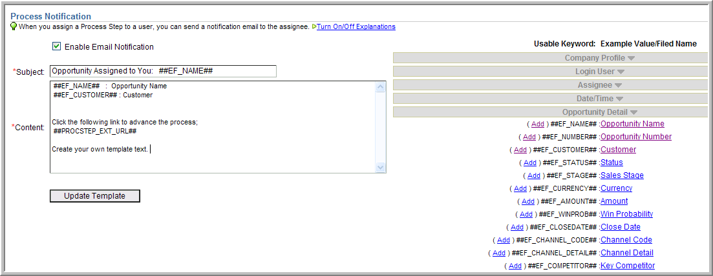

How to Build a Sales Process- Start with a Plan
- Start by Identifying your Sales Stages. Sales Stages are the mutually exclusive stages of your sales process. These categories should be broad definitions and may include; New Lead, Prospecting, Lead Follow up, Proposal, Negotiation, Sale Won, Sale Lost, and Dead Lead. Do not get too specific in your definitions; we will do that in the following steps.

Exercise: Turn a piece of paper horizontal or Landscape orientation, write your sales stages across from right to left. Put a box around each one.



- Within each one of the stages that you have just identified there are certain activities that must take place. Under each one of your Stages listed, add a list of the activities that should take place in each step. Use the following criteria for assistance:
  - Define Data Entry Updates: This includes any data fields that would be updated as the sales process is triggered to the current step. Example; in the Sale Won Stage, you would make the following updates;
  - Emails to be sent: Create a list of the emails to be sent. Templates will need to be created for each of the emails that you indicate here.
  - Tasks to be created: List all tasks that need to be done at that stage of the process.
  - Action that advances the Sales Process Step: This may be listed as a TASK. It is the one task that advances the process from the current step to the next step.

Example:
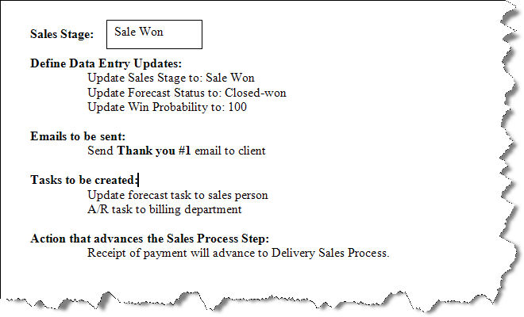

Creating a Sales Process using the Process Builder

Step 1. Identify your sales stages as steps 1a, 2a, 3a, 4a, 5a, etc.
Step 2. Enter your Process Steps as the actions that are required to move the sale from each of the stages. Label the action that is required to move the sale from 1a to 2a as Process Step 1b. Example: 1b: Make Initial Call. If one of the possible results of your “b” step does not advance your sale to the next sales stage, you may need additional process steps. Label the additional process steps as “c”,”d”, “e”, etc as needed.
Step 3. Link the results of the Process Steps.
Step 4. Add “Update Field Value” to Update the value of your sales stages at each step.
Step 5. Add non dependant Tasks/ Appointments/ Notes.
Be sure to mark you sales process as “Published” when completed. If left in the “Draft” mode, it will not be useable.

Location
Sales Processes can be seen in various places thru the application. Here are some examples of where the sales processes are accessed.
      - Attaching a Process to a New Opportunity:
      - Viewing the Process attached to an Opportunity from the Opportunity Detail page:
      - Administration of all Sales Processes
      - Reports for Sales Processes

Screenshot / Opportunity Summary page
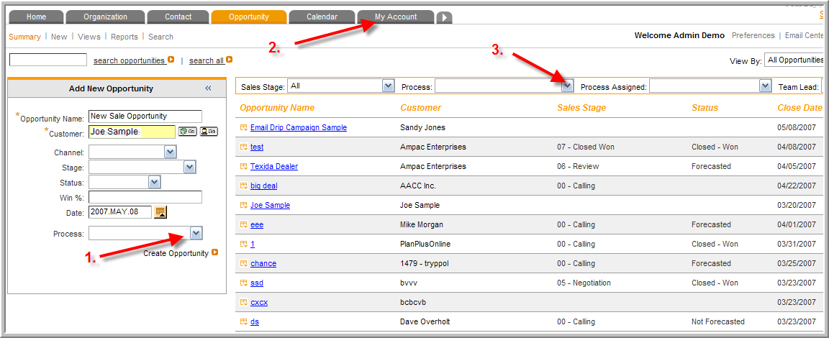
            - Identify which sales process to attach to a new Opportunity.
            - Administer all sales processes
            - Sort your summary view by a specific Process

Screenshot: Opportunity Detail Page >> Process Tab
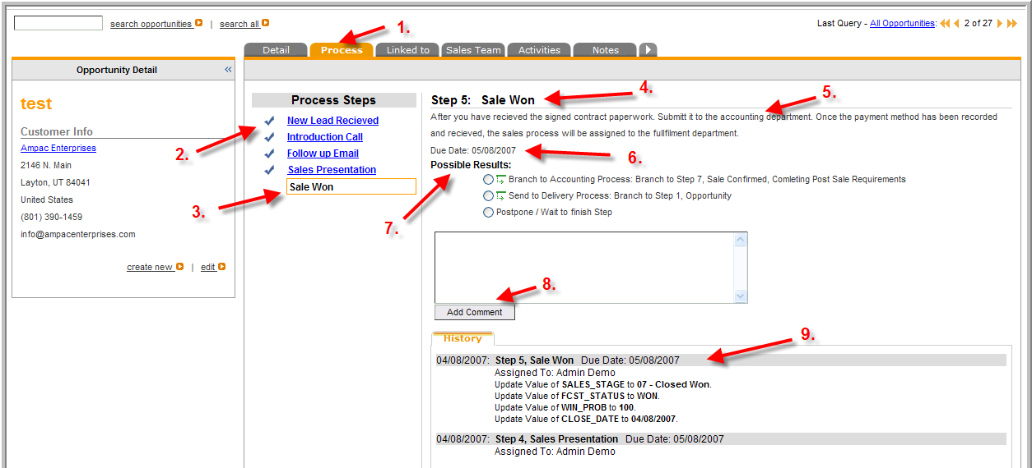
- The process tab is where you will find all of the details of the Process that is attached.
- Steps that have been completed will be marked with a Check
- The current step is highlighted with an orange box.
- The Current step is also visible at the top of the page.
- Scripts that have been added are displayed below the current step indicator.
- The Due Date of the Current Step. The due date will also be visible on the task list for the person that the current step is assigned to.
- Possible results of the current step. These results can branch between processes or within them.
- Add a comment without advancing to another step by typing in the box and click submit.
- The history of all previous activity. The assigned user of the current step is indicated here.

Screenshot: Administer Sales Process
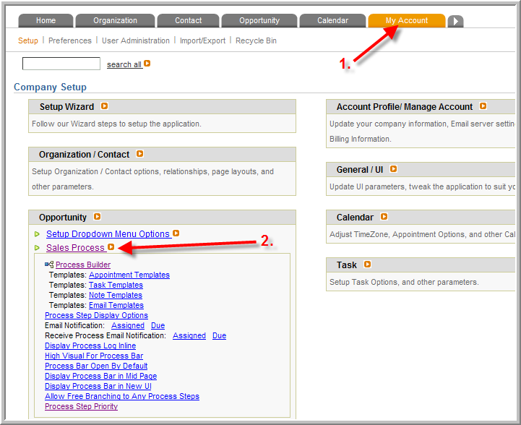
- Administer all sales processes options from the My Account Tab
- Select the Opportunity Box, then the Sales Process link.

Reports
The following reports are based on Sales Processes.
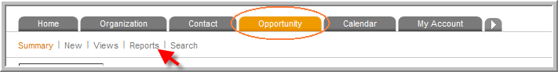
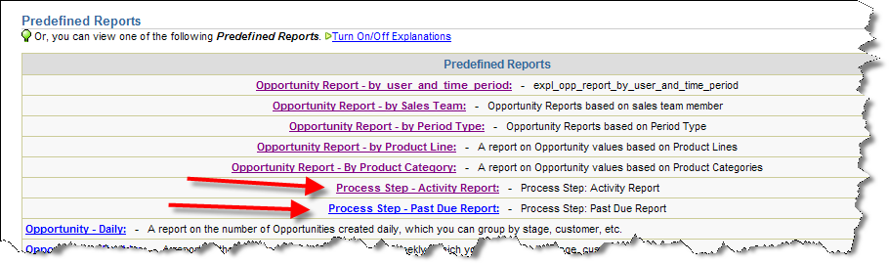
Process Step Activity Report
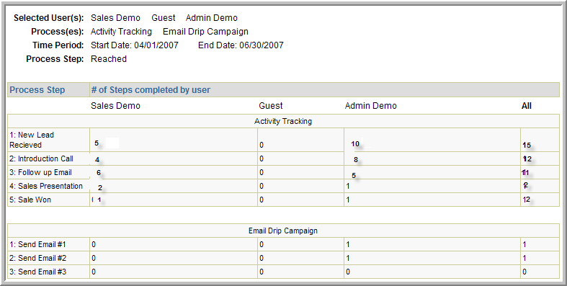

Overdue Process Steps
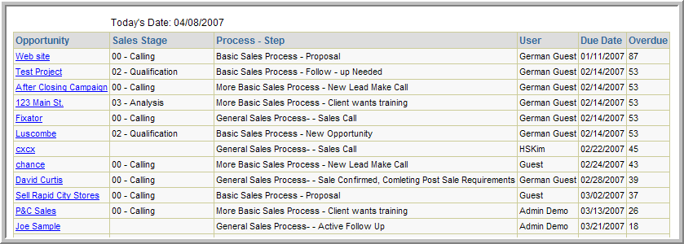

Process Step Report Options
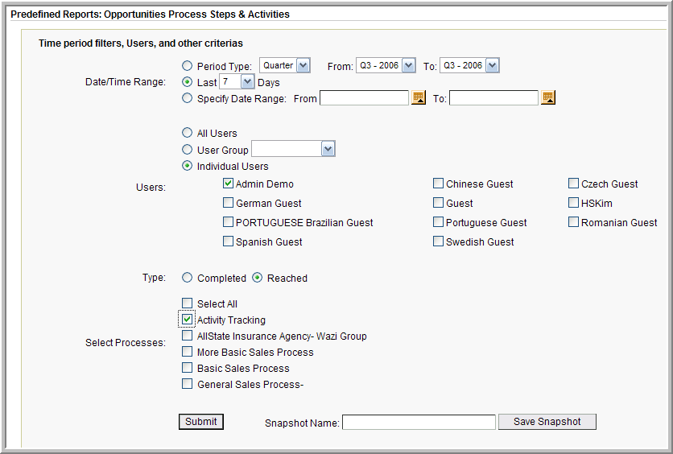
Type: Use “Completed” to report on the stages that have been completed.
Use the “Reached” button to include the process step that the opportunities are in currently.

See the “Demo” database to view more examples of how the sales processes can be used.

To log in to the Demo Database;
Go to www.planplusonline.com

Use the following account information;
Account Name: Demo
User Name: demo
Password: demo

