Creating a Sales Process
To create your own Sales Process in your PlanPlus Online Account, you must first create the steps in the Process Builder.

Step 1: Go to My Account-> Opportunity -> Sales Process-> Process Builder
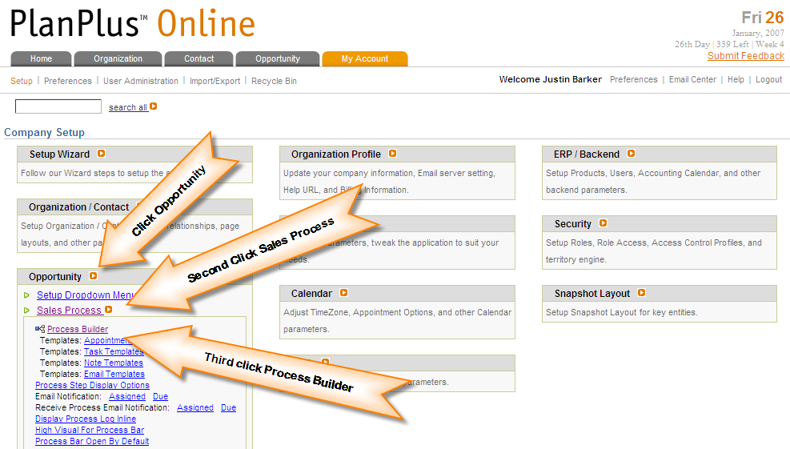

Step 2: Click Create New or You can clone the General Sales Process

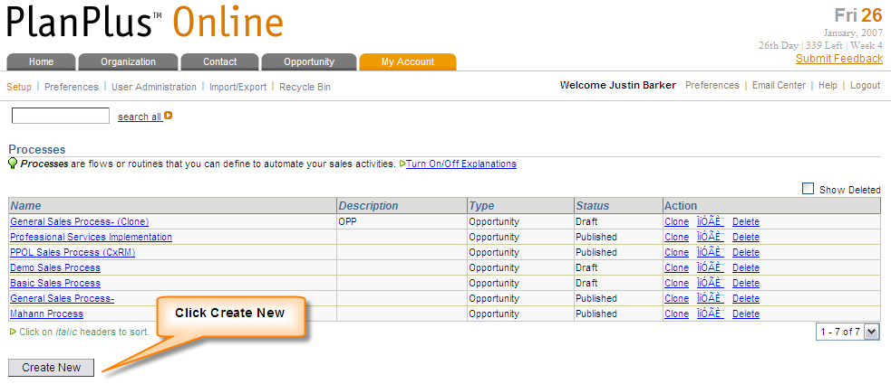

Creating a Sales Process

Step 3: Enter Sales Process and a brief description of the process-> Click Create Process
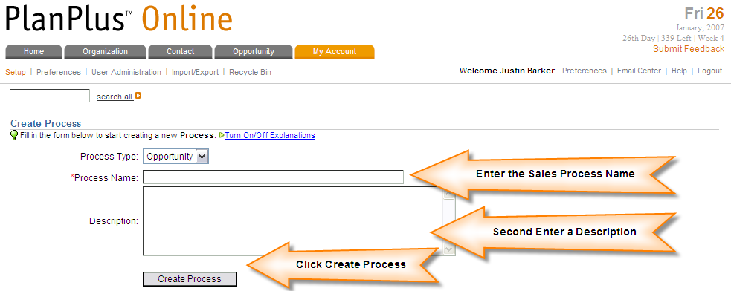

Step 4: Enter the First Step and click Submit.
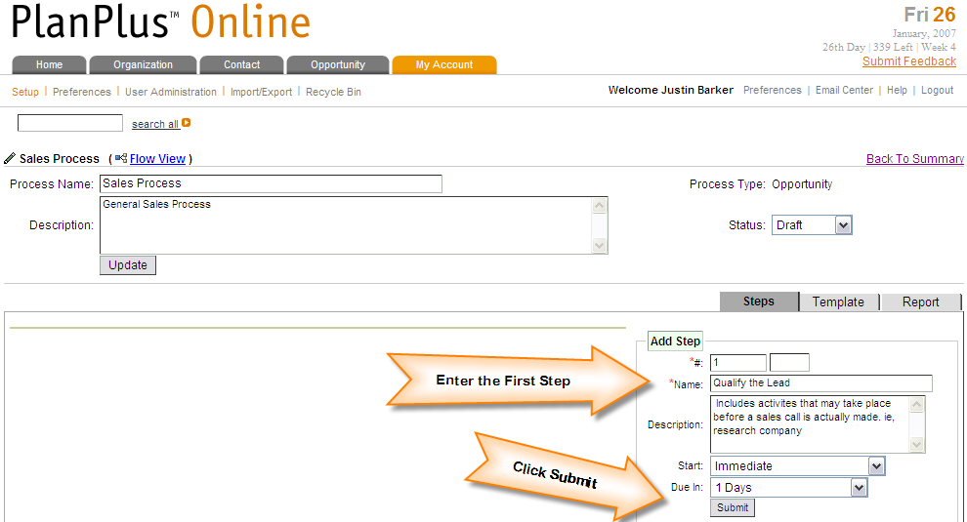

Creating a Sales Process

Step 5: Enter additional steps as necessary to the Sales Process; you can add sub steps to the process as well. You can also add when the next step in the process is due, in the “Due In” field. Once you have created your sales process you must link the steps together. Click the Edit Button next to the step name to edit advanced options.
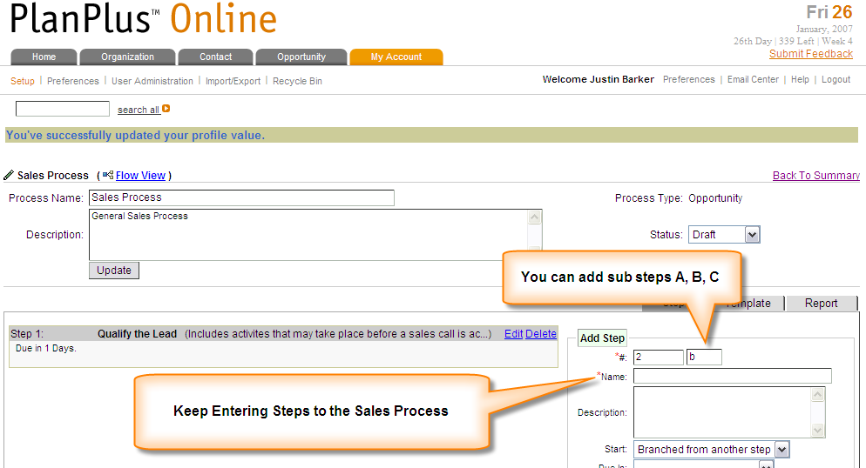

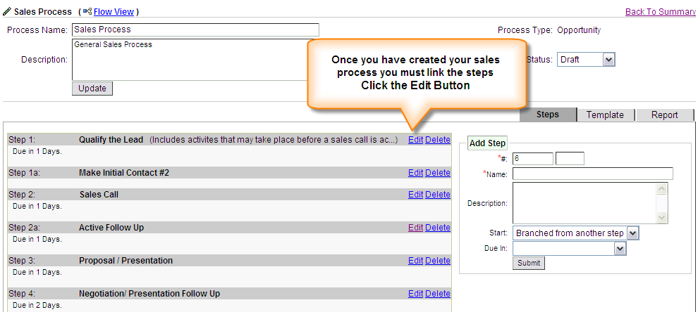

Creating a Sales Process

Step 6: Within each Process Step you can create Tasks and Appointments, send E-mails, and delegate the process to another user.

Assign To: Assign steps to other users in your company.

Actions: Automatically update “Field Values” in Contacts, Organizations, or Opportunities. Create Appointments, Tasks, and Notes. You can also send emails to contacts.

Results: Map any possible results of the current step to advance the sales process. You need to go through all the steps in your sales process. Map the results and actions that the step takes. (Remember to submit each step before going to another.) You can go back to you process steps by clicking on the highlighted sales process.

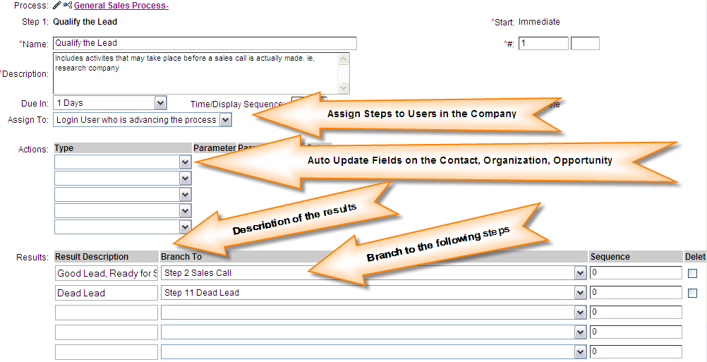

Creating a Sales Process

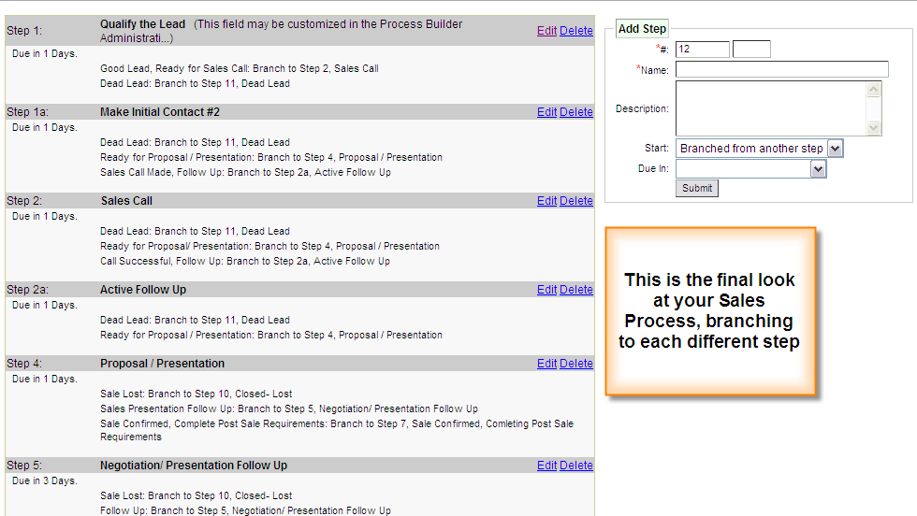

Step 7: Change the Status to “Publish”, and click the Update button. You have created your own custom sales process.

