Calendar / Time Zone
Setting the Time Zone: Click Preferences -> Scroll to User Interface-> Time Zone. Select the Time Zone you desire from a drop-down list. Click the Submit button.

Step 1:
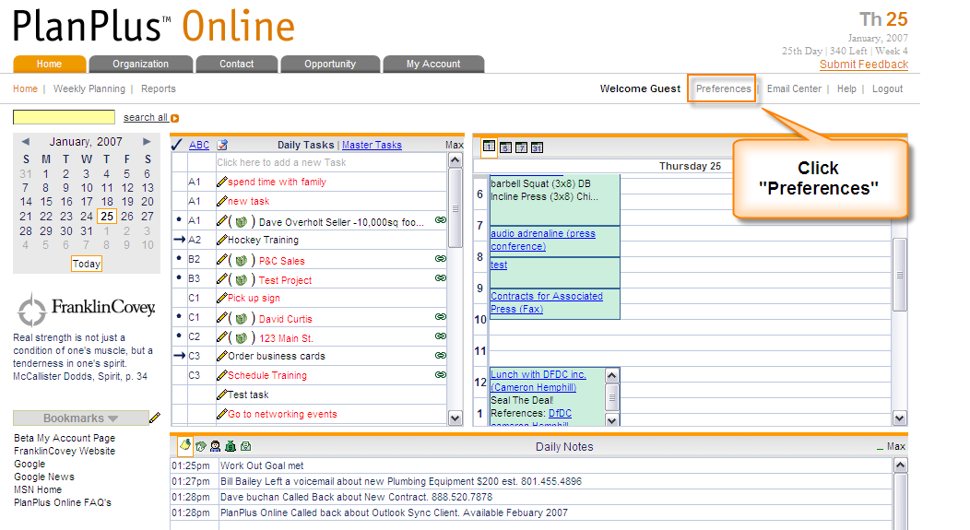

Step 2: Click the Change Time Zone dropdown to change Time Zone.
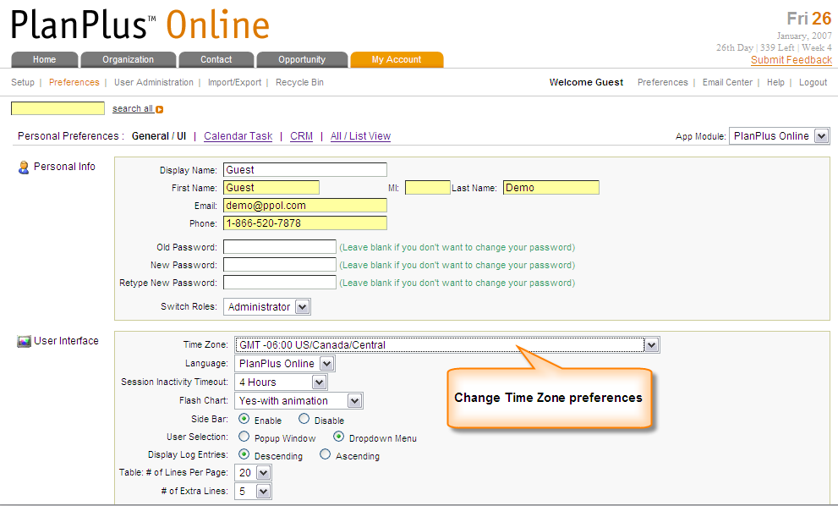
Step 3: Click Submit to save changes.

