How to import Contacts / Organizations from Microsoft Outlook

Step 1: In Microsoft Outlook Click File-> Import / Export
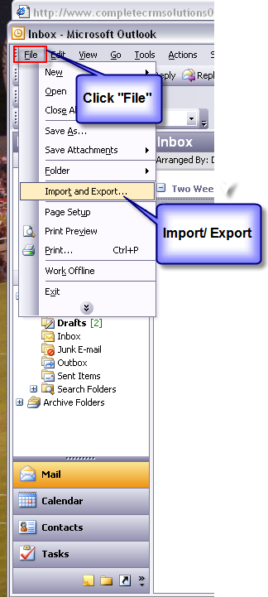

Step 2: Choose “Export to a file” and click “Next”
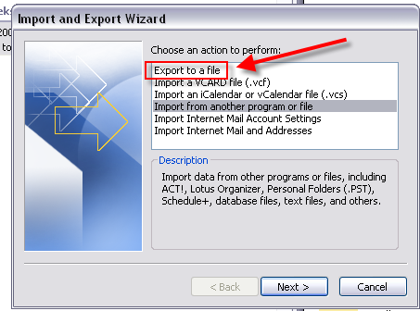

Step 3: “Create a file of type:”
Choose comma Separated Values (Windows)
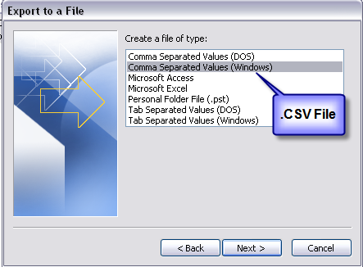

Step 4: “Select folder to Export From”:
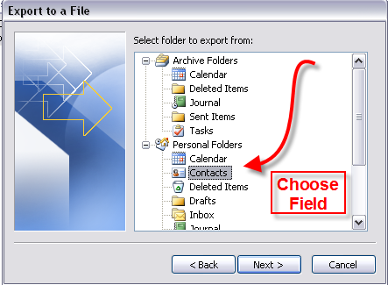

Step 5: Save the File to Access it again inside PlanPlus Online

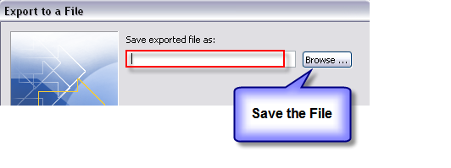

Step 6: Log into PlanPlus Online and select My Account

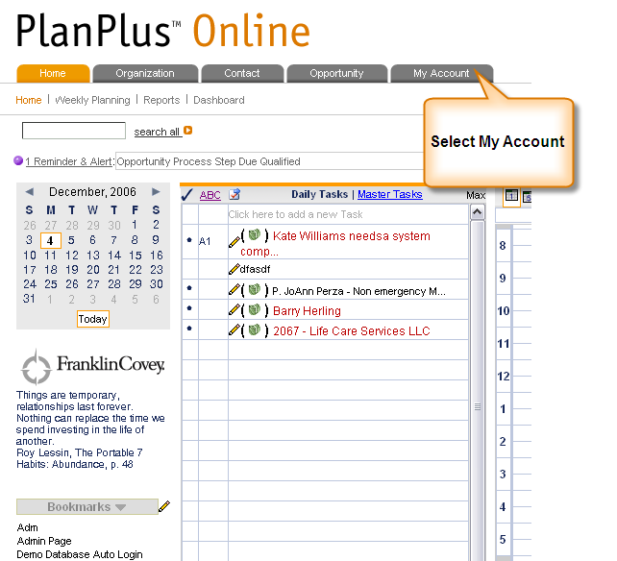

Step 7: Select Import / Export from the sub menu:

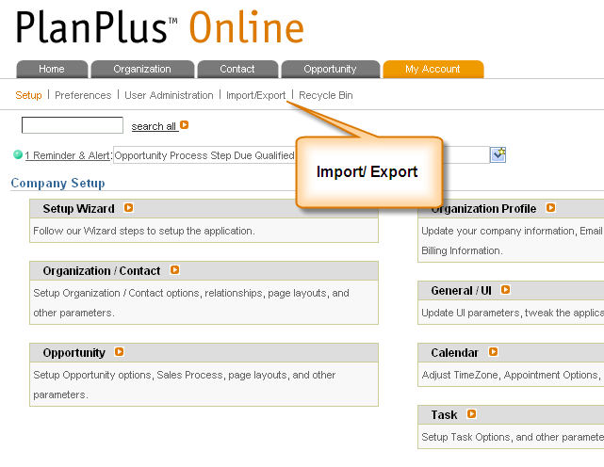

Step 8: Select which version of Outlook you use most users will select Outlook 2000 or 2003.

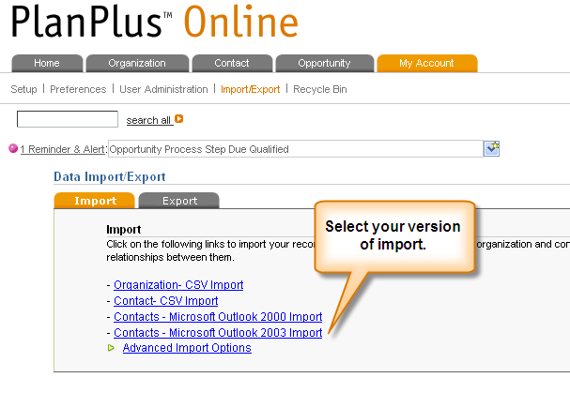
Step 9: Choose the file you saved from Outlook. Then either Rename or Record the Import Session ID listed. Click Submit.

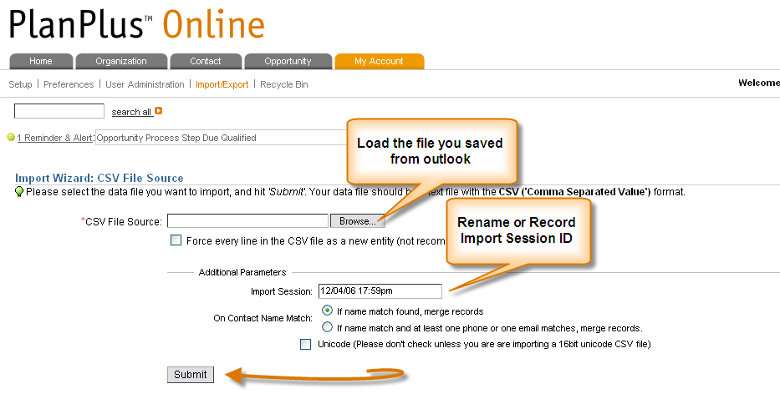

Step 10: Verify data is Mapped Correctly

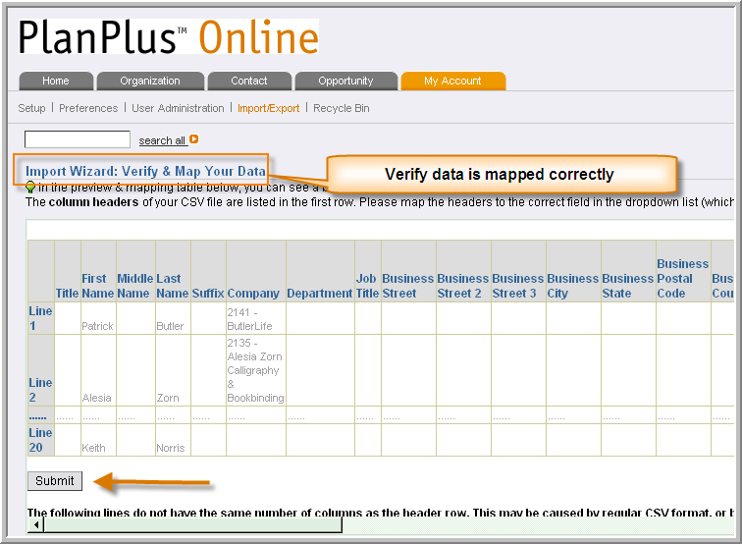

Step 11: The Contacts will load and process a final report before Entering in your system.

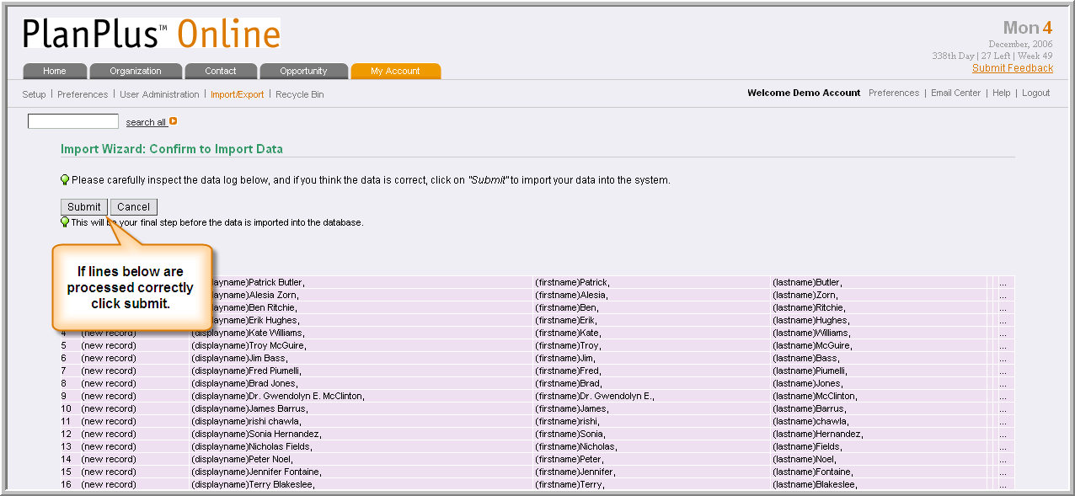

Step 12: Lines will be called and an Import History will be processed. Click on your contacts and the information should be loaded.

